Section 0 -Use GIT as local VCS. Steps to follow:

1. Create a directory ‘project_dir’ & cd to ‘project_dir’.
2. Initialize git version database. (git init)
3. Create a new file index.html.
4. Check the git status. You should find index.html as untracked file.

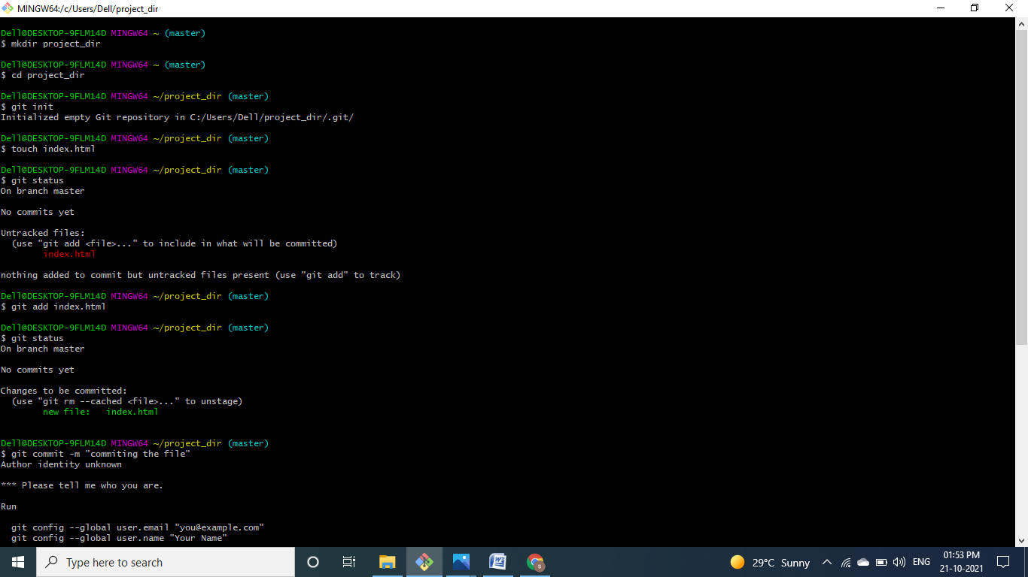

1. Stage the index.html file.
2. Commit index.html
3. Make few changes in index.html & create a new file info.txt file.
4. Check git status. You should find index.html & info.txt as untracked files.

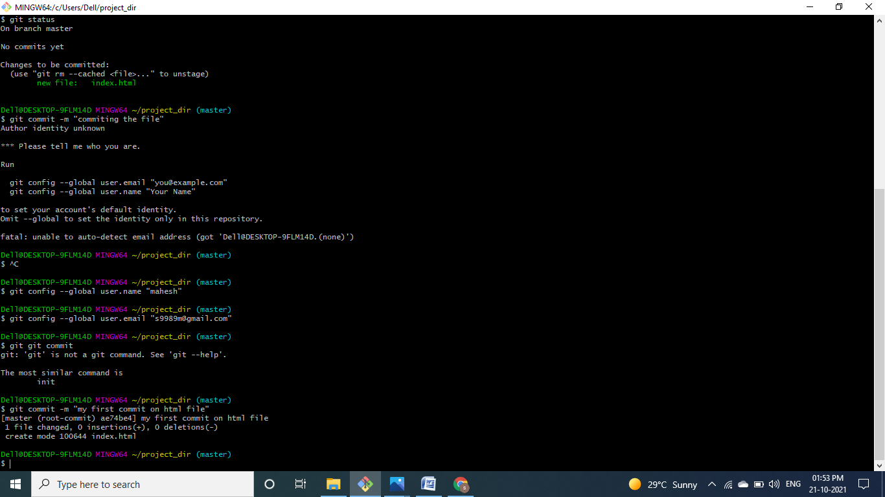

1. Configure GIT to ignore all txt files.
2. Again check the git status. You should find only index.html as untracked file.
3. State & commit index.html
4. Log all your comments so far.
5. Make some changes in index.html.

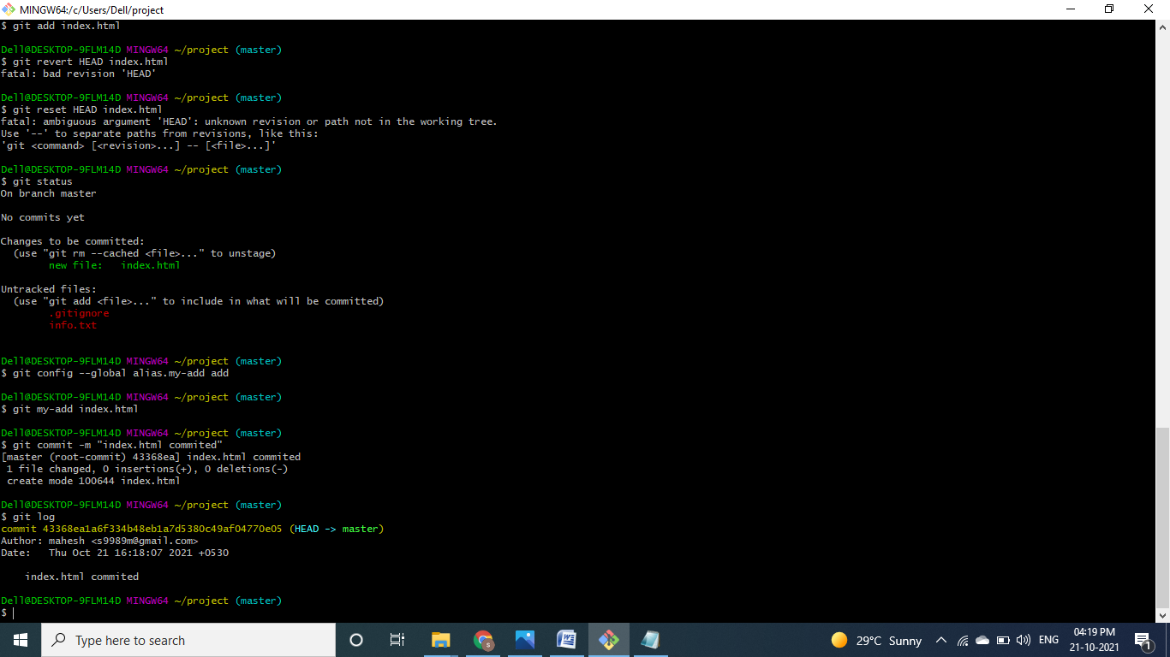

1. Stage index.html
2. Revert back the last stage.
3. Rename ‘add’ command to ‘my-add’

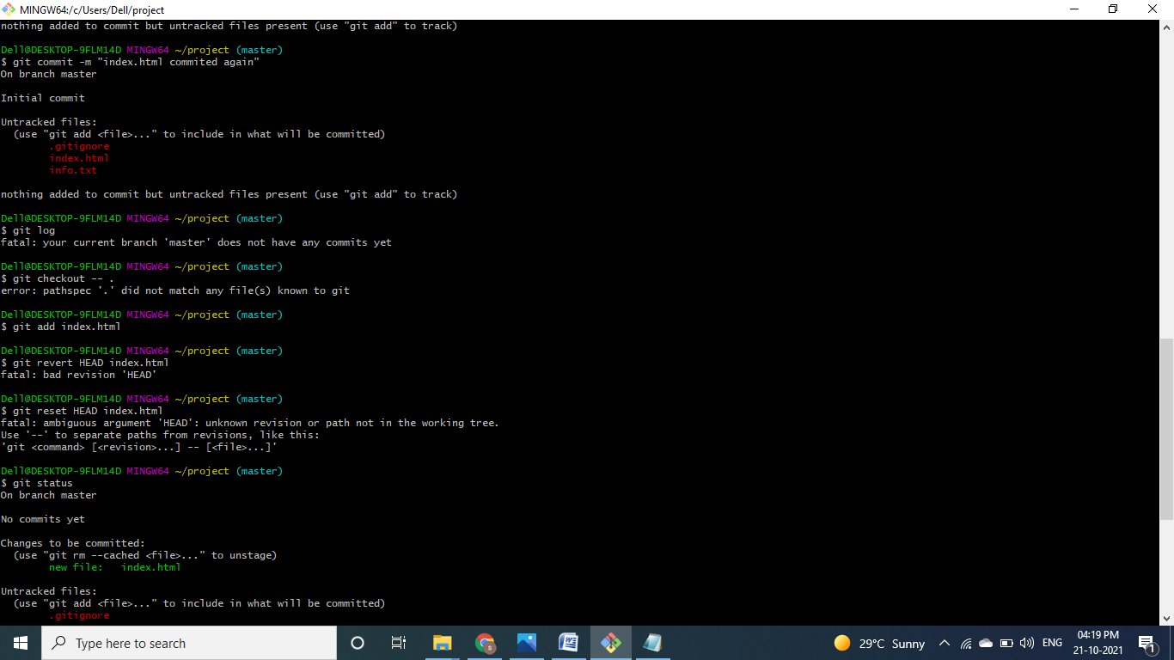

1. Using my_add command Stage index.html again & commit the changes.
2. Revert the last commit.

